 | Telford Sailing Club  2026 MEMBERSHIP Form | 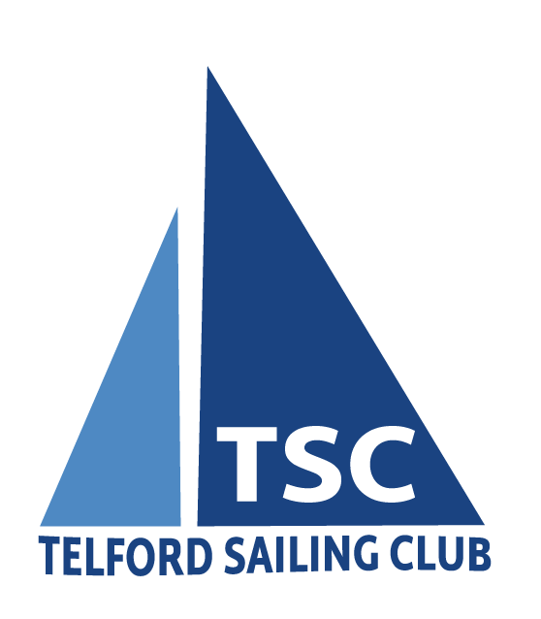
Please make cheques payable to Telford Sailing Club and send to;
Barry Phillips, TSC Membership Secretary, 27 Stretton Close, Sutton Heights, Old Park, TF7 5LS
Email: members@telfordsailingclub.co.uk
Or you can now pay by Bank Transfer. Sort Code is 090151. Account No. is 63308209. Use your surname as the reference. Ensure you send the completed Membership Form by email or post.

Membership Fees
Family Membership | £90.00
Single Membership | £80.00
Student / Junior | £70.00
Compound Fee | £65.00 per berth
Key Deposit | £32.00 This is a one off payment when you receive a key. Do not pay this every year
PLEASE PAY FEES BY April 1st (Full Year membership)

I AGREE TO DO DUTIES IF REQUESTED and abide by the rules and constitution of the club
Signature:
Surname:
Firstname:
Mr / Mrs /Miss /Ms:
Address:
Postcode:
Email Address:
Tel Number:

Family Members Only Section:
Spouse / Partners Surname:
Spouse / Partners Firstname:
Child 1 Name:
Child 1 Date of Birth:
Child 2 Name:
Child 2 Date of Birth:
Child 3 Name:
Child 3 Date of Birth:
Child 4 Name:
Child 4 Date of Birth:

Craft Registration
Make 1:
Sail Number 1:
Insurance Company 1:
Policy Number 1:
Make 2:
Sail Number 2:
Insurance Company 2:
Policy Number 2:

Summary
Date of Application:
Cheque Number
Payment by bank transfer: | Yes / No
Membership Fee
Compound Fee £65
Key £32
Total:

